Readings & Assignments: Week 1
Week 1 Readings
Complete the following readings early in the week:
- Week 1 online lectures
- From 3ds Max Help file, read the following topics:
  - UVW Map Modifier
  - Unwrap UVW Modifiers
  - Edit UVWs Dialog
  - Material Editor
  - Material and Maps
  - Render UVs
Week 1 Assignments Overview
Assignment Summary: Week 1 | Due Date
Assignment 1: Autobiography | Thursday, February 18, 2010
Assignment 2: Discussion Questions | Saturday, February 20, 2010
Assignment 3: Assigning UVW Coordinates | Sunday, February 21, 2010
Assignment 4: Arranging UVW Templates | Monday, February 22, 2010
Assignment 5: Final Project | Tuesday, February 23, 2010
Using the navigation on the left, please proceed to the next page.

Course Overview
Welcome to Computer 3D Modeling and Animation II.
Both modeling and animation are vital techniques for creating a successful
three-dimensional (3D) animated movie or a next-generation video game. However, they are not the only key elements. Animation and modeling are, probably, the most recognized aspects, but without material, textures, and a defining style, the aesthetics are lost.
Real-world objects have unique surface characteristics such as shine, roughness, and transparency, which can be defined for the models that you create in 3D. This process is called creating and assigning material to models. Once assigned proper material, models appear similar to real-world objects. You can create 3D models by manipulating polygon meshes and molding them into objects, characters, and scenes.
To animate, you need a model, and to enhance the look of that model, you need to apply material and textures. You have been exposed to 3ds Max in the course Computer 3D Modeling and Animation I and also to how the basic user interface and tools for modeling work. The software 3ds Max provides many tools that assist you in developing textures. It allows you to create UVW mapping solutions that can be exported to a two-dimensional (2D) paint program to create custom textures. These textures can then be applied back to the 3D object.
In this course, you will learn about the various techniques used in texturing, applying UVW coordinates, and unwrapping. You will also learn how UVW coordinates provide the ability to assign and create custom textures that enhance the look of different objects in a scene. In addition, you will be introduced to various animation principles and techniques, which will enable you to create models. You will also be introduced to linking and animation controllers and constraints.
Now, let's get acquainted with the weekly lecture topics.

Learning Outcomes:
- Create complex material and UVW mapping solutions.
- Demonstrate the ability to apply basic material to 3D models.

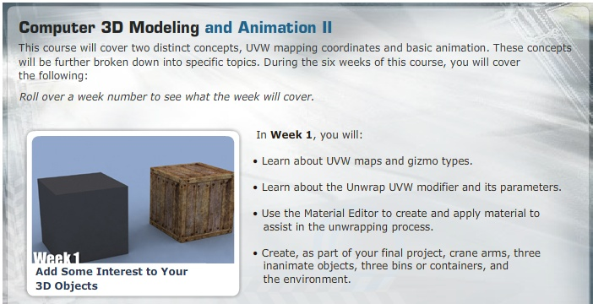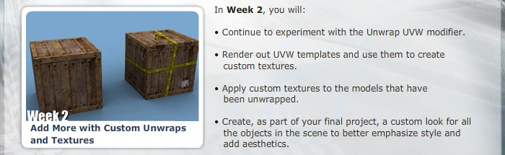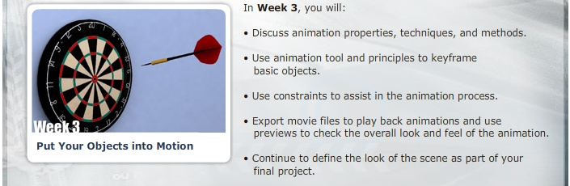

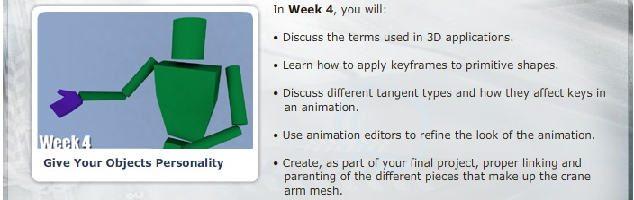
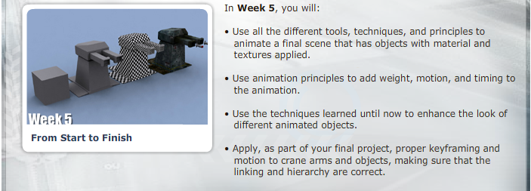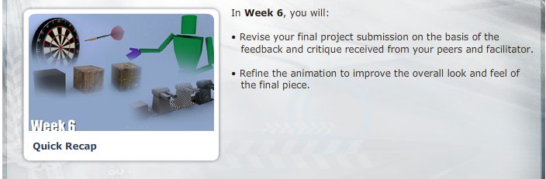

Week 1 overview
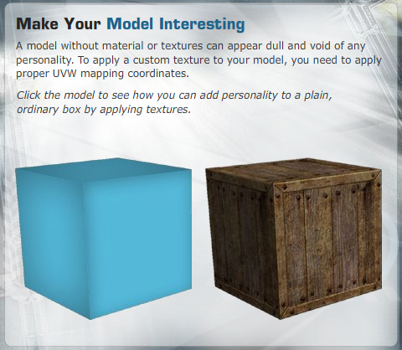
In Week 1, you will be introduced to UVW mapping coordinates and ways to manipulate them. You will also explore how 3ds Max helps in supporting, assisting, and manipulating objects. In addition, you will examine the surface direction of 3D models and learn how to apply proper mapping solutions to them.
Let's begin this week by learning about UVW mapping coordinates, how they are generated for primitives, and how custom coordinates are applied to primitives.

UVW Mapping Coordinates
UVW mapping coordinates define how a texture map is aligned to an object. These coordinates are expressed using U, V, and W dimensions. U is the horizontal direction, V is the vertical direction, and W is depth. You can manipulate these coordinates to fit a specific theme, concept, or style for a 3D object.
The software 3ds Max provides several tools that help in shaping and carving objects. These tools are called modifiers, which help you gain control over the mapping coordinates and manipulate the look of a 3D mesh surface. Modifiers are mainly found in the UV coordinates. They are used to define the coordinates for positioning material maps and include:
- Unwrap UVW
- UVW Map
- UVW Mapping Add
- UVW Mapping Clear
- UVW XForm
Modifiers have several parameters that can be manipulated to produce the desired results. To access the parameters of a modifier, you apply it to a primitive from the Modify panel. Depending on the modifier, you can control the tiling—the number of times a texture or map repeats over the UV directions.
Next, let's learn about UVW Map modifiers.

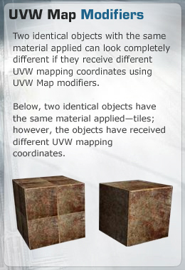
Once you apply mapping coordinates to an object, the UVW Map modifier controls how mapped and procedural material appears on the surface of the object.
Primitive objects, such as spheres and boxes, mesh objects, and patches generate their own mapping coordinates. You can enable the mapping coordinates by selecting the Generate Mapping Coordinates option for primitive objects. By default, this option is selected.
To customize or manipulate the generated mapping coordinates to fit a particular concept, you need to use UVW modifiers.
If you apply a UVW Map modifier to an object with built-in mapping coordinates, the applied coordinates take precedence over and cancel the preexisting coordinates.
An advantage of having 3ds Max generate mapping coordinates is that the coordinates are already laid out in the mapping space. A disadvantage is that 3ds Max creates seams where you do not want them or lays out clusters such that they don't fit the object's concept for a texture.
After mapping coordinates have been applied either automatically or with the UVW Map modifier, 3ds Max calculates the UVW coordinates on the basis of the shape and direction of the normals.
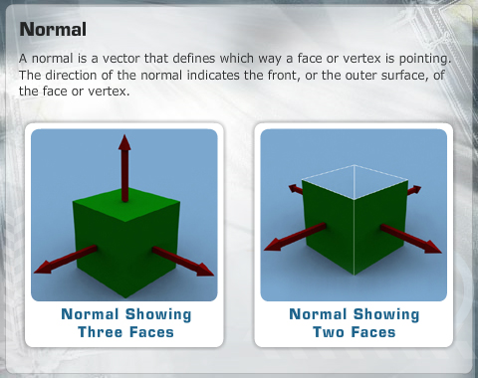

The UVW Map modifier is the primary tool for controlling the mapping of an object. The modifier consists of seven different mapping options known as UVW gizmos. Each gizmo wraps the map in a different way.
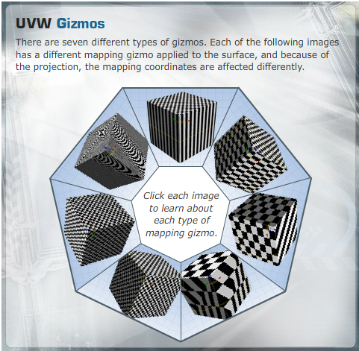
Each one of these UVW gizmos projects the mapping coordinates onto an object. It is important to pick the mapping type that best suits an object's shape. A mapping gizmo can be transformed to help fit an object or a specific face of an object.
When you transform a mapping gizmo, it affects the look of the texture that will eventually be applied to the object. The gizmo can also be used to control the tile and direction of the UVW coordinates.
Different alignment parameters for a gizmo affect how well that projection fits the shape or section of specific polygons. It is possible that not all sides face the X, Y, or Z direction. They could be somewhere in between, and therefore, the alignment of the UVW gizmo is important for correcting any distortion.
Next, let's learn about the Unwrap UVW modifier, which can be used to unwrap the existing mapping coordinates of an object.
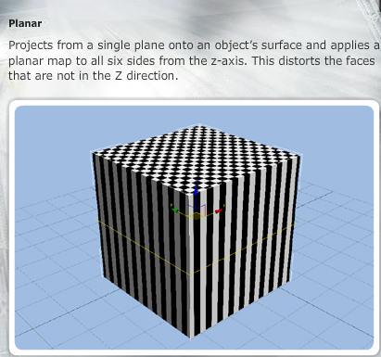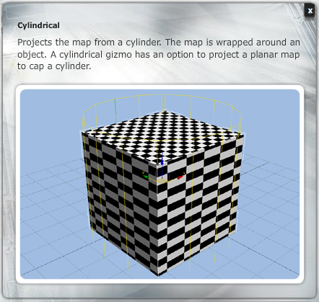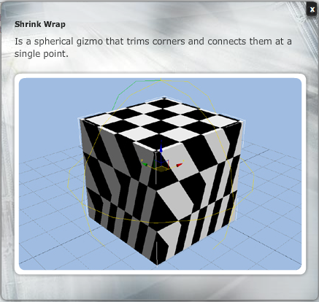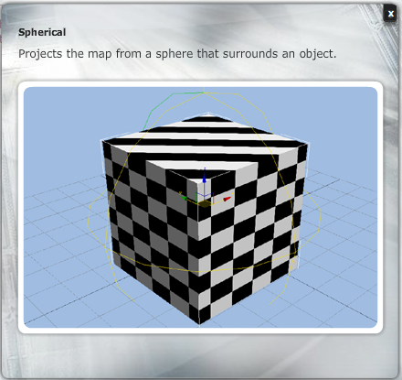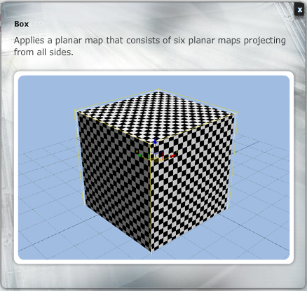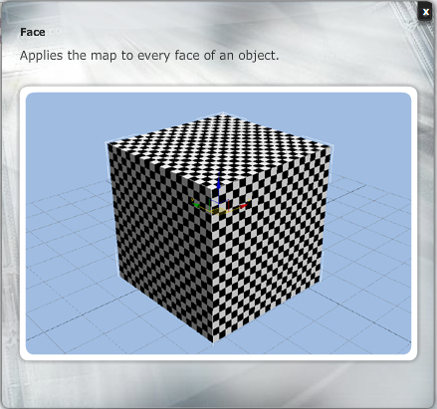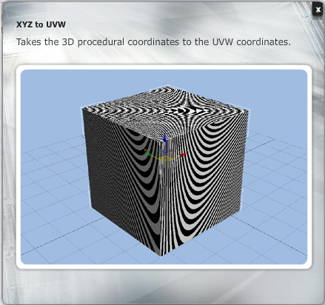

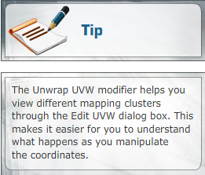
Unwrap UVW Modifier
In 3ds Max, the most powerful tool for applying and manipulating mapping coordinates is the Unwrap UVW modifier. This modifier contains parameters that can be found within other UVW modifiers, but it also includes more powerful tools that help in creating mapping solutions for a simple or even an extremely complex mesh.
Some of the tools that help you create mapping solutions include:
- Map seams
- Average normals or quick planar mapping
- Normalize Map
- Mapping (texture) space

Map Seams
Map seams are the spaces or breaks between different UVW mapping clusters. Seams are visible by default and can be either turned off or made more noticeable.
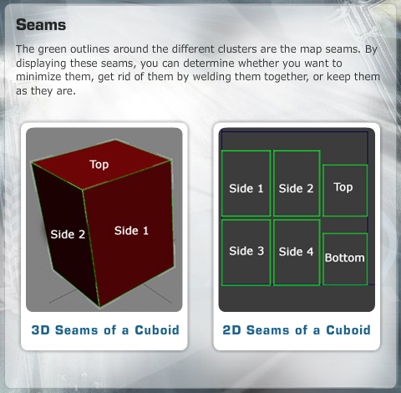

Average Normals or Quick Planar Mapping
As you already know, sometimes, not all sides of a 3D model are in the X, Y, or Z direction but are somewhere in between. In such cases, the Unwrap UVW modifier helps you select a polygon or a group of polygons. The modifier then calculates the average of the direction and places a planar mapping gizmo. This is a quick and easy way to assign different planar mapping coordinates to a single polygon or to a group of polygons.

Normalize Map
The Normalize Map option will help you determine if the assigned mapping coordinates fit into the standard mapping space or retain the actual size of the object. When the Normalize Map option is selected, the object fits the mapping space, and when the Normalize Map option is cleared, the mapping coordinates display the actual size of the object as it was created.

Mapping (Texture) Space
When you create an object's mapping coordinates, it is important how you organize the different clusters. Once the coordinates are arranged in the mapping space, you can use that information to create a texture for the UVW template. When creating textures that are applied to 3D objects, you can use some standard square pixel maps so that the UVW template that contains the different clusters resembles the mapping space. Placing all the different mapping clusters into the defined space will help you keep the clusters organized. You can also render and manipulate the clusters easily in other 2D applications.
Next, let's learn how the Material Editor defines the look of your object.

Applying Material
The Material Editor is a powerful tool that defines the look of objects and uses UVW mapping coordinates to assign material to objects. The Material Editor of 3ds Max creates, manipulates, and assigns different maps to objects in a scene. Once you have assigned coordinates to an object and created its texture, you apply that texture to the object.
The Material Editor is where the transformation begins. Shortcomings in a model can be remedied with the use of detailed material. The Material Editor is made up of sample slots in the upper portion and material-specific parameters for the selected material in the lower section.
The Material Editor can be used to apply not only textures created from a UVW template but also specific material that can be used in the UVW mapping creation process. Procedural maps that exist in the Material Editor's library can be used to see how the mapping is coordinated and whether the maps are being assigned correctly. Maps are assigned to different attributes of material. For example, a bitmap is assigned to the Diffuse map slot of a Blinn material. Maps are assigned to material, and then the material is assigned to a mesh.
Applying a map to an object before unwrapping will show how the object is being projected onto the surface of a mesh. This will allow you to see whether there is any distortion in the mapping coordinates.
Applying material to an object is a fairly simple task. Let's learn how to do so.

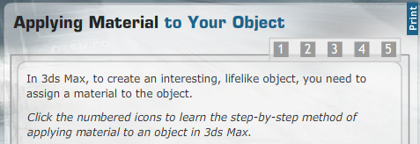
Step 1: Open the material editor and apply a map to the diffuse slot.
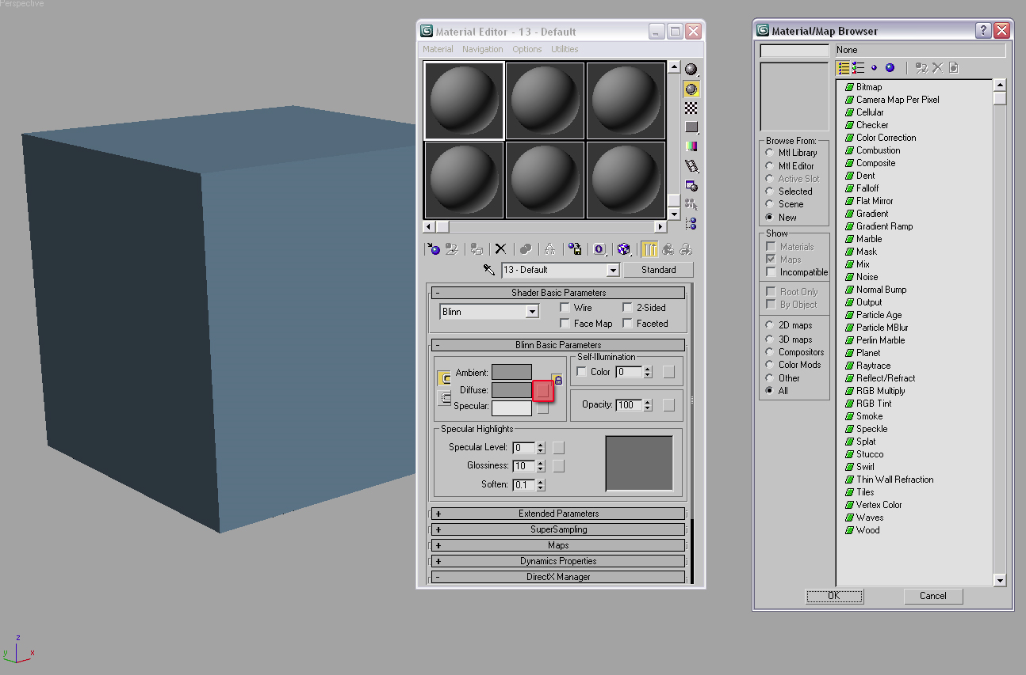

Step 2: Select the texture you want to use as a bitmap image.
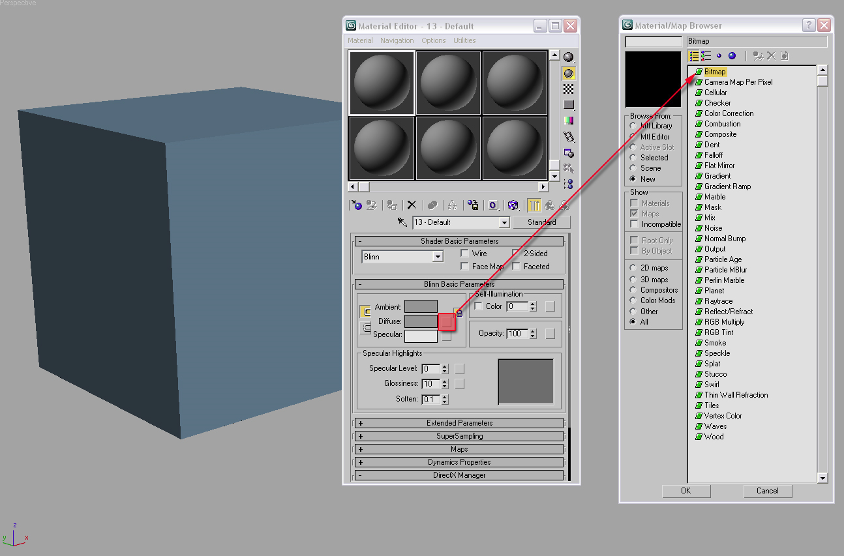
Step 3:The bitmap image appears in the diffuse map slot and appears on the selected material. The material can now be assigned to the object.
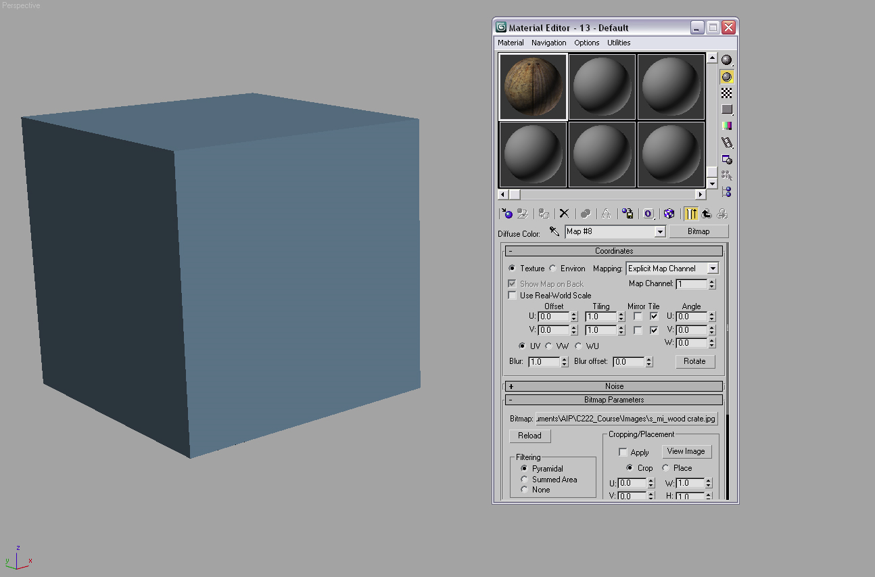
Step 4: Assign the selected material to the selected object or drag the material onto the object in the viewport.
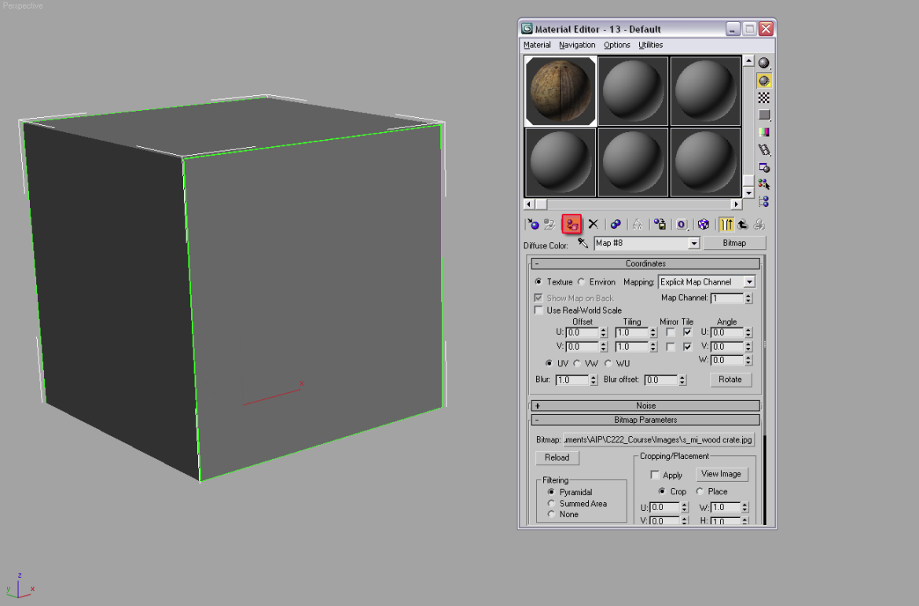
Step 5: View the assigned material in the viewport. Make sure that the viewport is set to smooth and highlights.
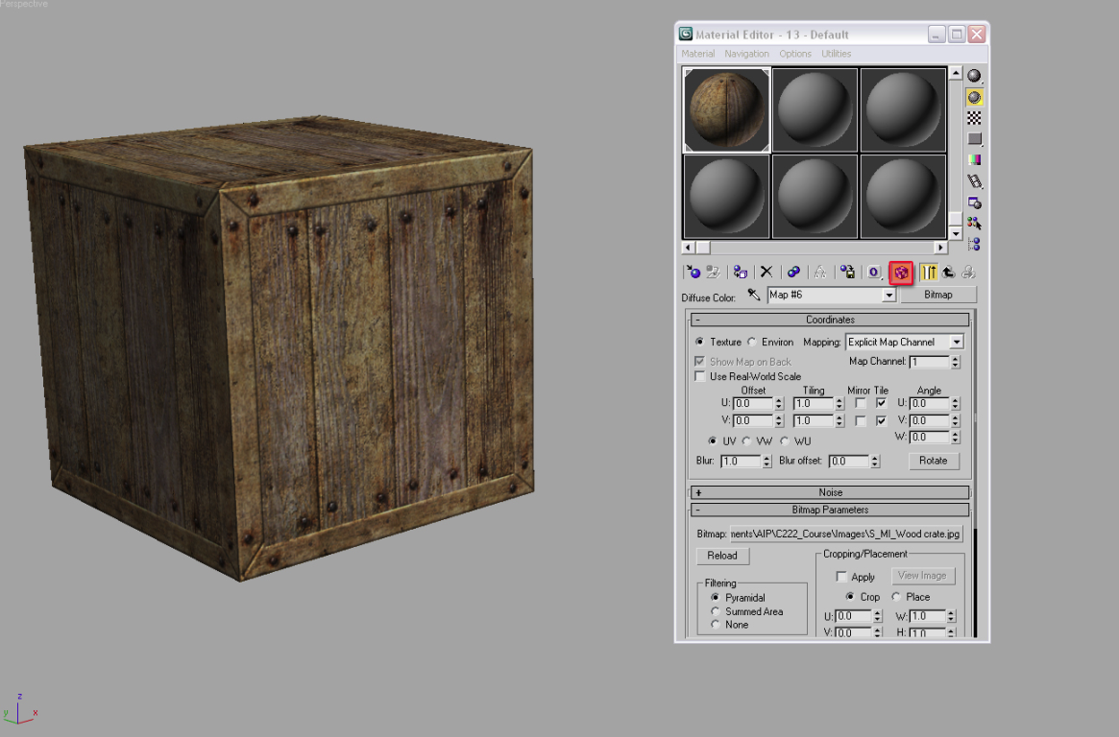
After the mapping clusters have been defined and their orders placed into the texture space, the UVs are ready to be rendered and used. Next, let's learn about rendering UVs.

Rendering UVs
Rendering UVs and UV Templates
Using custom UVW mapping coordinates is extremely beneficial if they are rendered out and used to create textures in 2D paint applications, such as Photoshop.
After you have mapped all the UV coordinates onto a model, you can paint the desired textures and then load them back into the Edit UVWs window, where they can be aligned to the correct UVs.
Using the Render UVs menu command, you can create a template that can be saved and loaded into Photoshop, showing you exactly where the UV boundaries are.
The Render UVW Template menu command opens the Render UV dialog box, which lets you set the template’s dimensions and colors and shows overlaps and seams.
Before rendering out UVs, make sure that you clean up all issues with seams and distortion and determine the size of the texture you will create.
Before rendering a template, it is important to know whether there are any limitations on size. If you start with a small, square pixel texture, you will be unable to enlarge the map without possibly distorting the texture. In addition, when working on a specific project, such as a video game, there might be a limitation on the texture size because of the space allotted for textures.

Summary
This week, you were introduced to UVW mapping and how it affects the look of 3D objects. You also learned about the Material Editor and how it helps in the unwrapping process.
Next, you discussed a few modifiers that are used to manipulate and assign different mapping coordinates. Some modifiers are powerful and can be used to tackle most of the required modifications.
Finally, you discussed the importance of organizing mapping clusters. Knowing how different clusters are assigned, transformed, and organized will help you determine how the eventual texture will be assigned to an object in a 3D environment.
In Week 2, you will build on the techniques and tools learned in this week and learn more about the Unwrap UVW modifier.

Assignment 1: Autobiography
Before you begin, spend some time to get to know your peers. You may read the facilitator’s autobiography posted in the Discussion Area. By
Thursday, February 18, 2010, write a brief autobiography of at least 100 words discussing the following details:
- Your name and location
- Profession or area of study
- Level of familiarity with 3D software
- Academic or professional strengths
- Reason for interest in the topics covered in this course
- Expectations from this course
Read, respond, and discuss the following questions to share your views on various aspects of 3ds Max with your peers:
- What are some of the things you look for in a video game or an animated 3D movie? Provide a rationale to support your answer.
- List at least three principles of animation and describe their importance to 3D animation.
- Describe either a video game or a 3D-animated movie that you feel represents good use of animation principles or texturing techniques.
Comment on at least two of your peers’ autobiographies. You may ask questions or respond generally to the overall experience.
Consider the discussions as a way of communicating your ideas and opinions in a traditional classroom. Be clear in your communications. Format your autobiography according to MLA guidelines.
Assignment 1 Grading Criteria | Maximum Points
Wrote a short autobiography with the elements listed and communicated ideas and opinions explicitly and clearly in writing. | 8
Commented on at least two replies to other autobiographies posing questions and observations to enrich the discussion and displaying positive regard for others. | 4
Provided rationale and examples to support your response to the three questions regarding texturing and animation. | 8
Total: | 20
For assistance with any problems you may have when completing this assignment—OR—to offer your assistance to classmates, please use the Problems and Solutions Discussion area located through the left side navigation link.

READ FIRST!
Welcome to a new class gang. Whenever you see one of these "READ FIRST" postings please read the instructions in them. Usually they will point out or complement the information about what you must do in that assignment.
In this, for this first assignment, this is very simple- write your autobiography following the instructions above and post it here. Once you are done make sure to reply to at least two of your peers. Participation points add up a lot and can affect your grades for the better or the worse.
Assignment 2: Discussion Questions
By Saturday, February 20, 2010, respond to the discussion questions assigned to you by the facilitator. Submit your responses to the appropriate Discussion Area. Start reviewing and responding to your peers’ posts as early in the week as possible. You can ask a question, post a comment, or add a point to expand the discussion. Be honest, clear, and concise.
Always use constructive language, even in criticism, to work toward the goal of positive progress. Make sure to use your course text or other research when possible in your responses.
Support your statements with appropriate references wherever necessary. Follow current MLA guidelines for writing style, spelling, grammar, and citation of sources.
Assignment 2 Grading Criteria | Maximum Points
Response Criteria:
Met the criteria for the correct responses to the questions assigned. | 4
Used vocabulary relevant to the current week’s topics—at least five terms. | 4
Participation Criteria:
Used vocabulary relevant to the current week’s topics—at least five terms. | 4
Participated in the discussion by asking a question, providing a statement of clarification, providing a point of view with a rationale, challenging a point of discussion, or making a relationship between two or more points of the discussion. | 4
Justified ideas and responses by using appropriate examples and references from textbooks, Web sites, and other references or personal experience. | 4
Total: | 20
For assistance with any problems you may have when completing this assignment—OR—to offer your assistance to classmates, please use the Problems and Solutions Discussion area located through the left side navigation link.

This week answer questions 1 and 2. They relate to understanding teh concept behind UVW coordinates and mapping, a process we will study in detail. Post your answers here and reply to the answer of, at least, two of your peers.
DQ 1
What are UVW coordinates, and what do U, V, and W describe? Why is it important to assign proper UVW coordinates to 3D models? Would you be concerned with creating UVW mapping coordinates? Why or why not? Justify your answer with appropriate rationale.
DQ2
Why do you think it is important to have materials assigned to the objects to assist with the unwrapping process? What is the most suitable procedural map to be used on a material and eventually assigned to an object?
What is the most suitable procedural map to be assigned to a material to help with the unwrapping process? How does having that material assigned to an object help? Explain your answers using appropriate examples and rationale.
DQ3
When working with complex or organic models such as a character, why is it important to minimize distortion in the UVW coordinates before applying a texture? Explain what might occur if mapping coordinates were not addressed.
DQ4
After an object’s UVW coordinates have been manipulated and corrected and stretching has been minimized, do you think utilizing texture space in the Edit UVWs window is required? Why or why not? If mapping coordinates are outside of the defined texture space, how would that affect the texture once applied to the unwrapped object?

Assignment 3: Assigning UVW Coordinates
In this assignment, you will practice assigning UVW coordinates to a cube.

Perform the following:
- Create a box that has equal sides (a cube) and modify it to separate its UVW mapping coordinates.
- Make sure that the cube has the proper UVW maps so that the different coordinates can be manipulated.
- Organize, transform, and arrange the mapping coordinates properly to give the cube’s UVWs a clean unwrap.
- Save the file with the cube and the mapping coordinates as W1_A3_LastName_FirstName.max and submit it to this Discussion Area by Week 1, Day 4.

Discussion
By the end of the week, use this Discussion Area to discuss the following:
- Discuss some challenges that you came across while trying to create the cube’s mapping coordinates for all six sides.
- Describe at least one modifier assigned to the cube to assist with the manipulation of its mapping coordinates and discuss how it helped.

Critique Exercise
By the end of the week, use this Discussion Area to review and comment on the assignments posted by at least two of your peers. Comment on whether or not they organized all six sides of the cubes, mapping coordinates correctly. Also provide constructive feedback if the mapping (texture) space was used as efficiently as possible.
Assignment 3 Grading Criteria | Maximum Points
Used 3ds Max to create a cube and assigned specific UVW coordinates to each of the six planar sides. | 5
Organized the six individual planar UV sections of the cube in the texture space. | 5
Made sure all six sides fit into the texture space and used texture space as efficiently as possible. | 5
Discussed any challenges that might have made it difficult to assign planar mapping coordinates to the six sides. | 5
Discussed some of the different techniques used to create UVW coordinates. | 5
Reviewed and critiqued the submissions of at least two peers on the basis of the critiquing guidelines. | 5
Total: | 30
For assistance with any problems you may have when completing this assignment—OR—to offer your assistance to classmates, please use the Problems and Solutions Discussion area located through the left side navigation link.
Follow the instructions in the assignment header to create the test object and practice unwrapping. After you have completed the steps use the naming convention described in the instructions to name your file and post it in the discussion area.
If the file is too large for the Discussion Area then post in the Doc Sharing area. Afterwards post a comment in this thread to inform the rest of us where the file is and to give us a place to provide you feedback.
Finally, comment on the work of your peers as usual.
- Discuss some challenges that you came across while trying to create the cube’s mapping coordinates for all six sides.
- Describe at least one modifier assigned to the cube to assist with the manipulation of its mapping coordinates and discuss how it helped.

Assignment 4: Arranging UVW Templates
After practicing to assign UVW coordinates to a cube, you’ll now use a box with unequal sides and create a proper mapping solution to minimize stretching.

Perform the following:
- Create a box with unequal sides and modify it to separate its UVW mapping coordinates.
- Make sure that the box has the proper UVW maps so that the different coordinates can be manipulated.
- Organize, transform, and arrange the mapping coordinates properly to give the cube’s UVWs a clean unwrap.
- Make sure to minimize distortion and stretching in the UVW mapping coordinates and to assign a material that has a checker map assigned to the diffuse slot.
- Export the UVW mapping coordinates as a 1,024 x 1,024 square pixel texture.
- Save your work as W1_A4_LastName_FirstName.max. In addition, save the UVW template as W1_A4_LastName_FirstName.jpeg. Submit both the files to this Discussion Area by Monday, February 22, 2010.

Discussion
By the end of the week, use this Discussion Area to discuss the following:
- How did assigning a material with a checker map to an object assist with unwrapping?
- What were some noticeable differences between assigning UVW mapping coordinates to the cube in the previous assignment (all sides even) and the box (with unequal sides) in this assignment?

Critique Exercise
By the end of the week, use this Discussion Area to review and comment on the assignments posted by at least two of your peers. Comment on:
- How have the UVW coordinates been applied?
- Are there any stretching issues that need to be fixed?
Assignment 4 Grading Criteria | Maximum Points
Used 3ds Max to create a box with unequal sides and assigned specific UVW coordinates to each of the six planar side. | 5
Organized the six individual planar UV sections of the box in the texture space. | 5
Made sure all six sides fit into the texture space and used the texture space as efficiently as possible. | 5
Assigned a check material and used that map to minimize stretching in the box. | 5
Exported the UVW template as a .jpeg file. | 5
Discussed why a checker map is applied to a 3D object and how is it used to help with UVW coordinates. | 5
Reviewed and critiqued the submissions of at least two peers on the basis of the critiquing guidelines. | 5
Total: | 35
For assistance with any problems you may have when completing this assignment—OR—to offer your assistance to classmates, please use the Problems and Solutions Discussion area located through the left side navigation link.
This assignment is similar to the previous one but will bring to the table the most common situation we face when dealing with mapping objects: uneven surfaces. Just like before follow the instructions in the assignment and use the suggested naming convention. And to clarify, with uneven surface we are talking about moving a few vertices in opposite directions, scaling one side more than the other, and/or moving an edge further to one side. Don't simply scale a cube on one axis and call it a day.
If the file is too large for the Discussion Area then post in the Doc Sharing area. Afterward post a comment in this thread to inform the rest of us where the file is and to give us a place to provide you feedback.
Finally, comment on the work of your peers as usual.

Assignment 5: Final Project

Final Project Overview
The goal will be to built, texture and animate a vehicle in a matching style environment. The vehicle should be very creative and unique in design (possibly more futuristic)
The vehicle is to be unique in design. The goal is to make the vehicle design futuristic but highly functionable. For example a car can be designed, but it should look like a futuristic car and match well in the environment. Detail is critical but the model must not exceed 3000 polygons.
The environment should match the concept design of the vehicle. The environment needs to have elements that can be animated. Things like lights and cameras do not count but can be in the environment. The animated objects should be props that possibly the vehicle can interact with, such as a bridge, doors or barriers.
Week-wise distribution of the tasks of the final project:
Week 1 | Start the modeling of the vehicle and environment. Concept sketches for the vehicle should be required also. There should be at least 4 animated objects within the environment.
Week 2 | Finish building the vehicle and environment and begin to think about textures. Be sure the models are texture ready by cleaning up any extra polygon faces. Be sure the vehicle polygon count is under 3000 and the environment is under 5000 polygon count
Week 3 | Design and begin to texture your vehicle and parts of your environment. Be sure to use a 2D paint software to design custom textures.
Week 4 | Start to animate your vehicle. Think about moving parts and how they will affect the environment. Begin to animate the areas of the environment also. Do a few motion tests of the animation.
Week 5 | Continue to animate both the vehicle and parts in the environment. Be sure to use constraints and other animation techniques to make the animation believable. Post the final animation for critique
Week 6 | From the feedback make any needed changes to the animation and resubmit

Creating the Scene
As part of this week’s final project component, you will start thinking about the concept designs of both the vehicle and environment. You should begin to create concepts for the look and style of each that will make up your final scene. Using proper techniques and principles, you will begin modeling the vehicle and environment

In this assignment:
- Create concept designs of the vehicle and environment. Post at minimum 3 design for each. Put all the designs into a PDF document. Save the file as W1_A5_LastName_FirstName.pdf
- Start to model the vehicle frame.
- Block out the areas and parts of the environment. Then start to model some of the environment.
- Make sure all objects in the scene are named appropriately for easy identification.
- Save the modeling files as W1_A5_VehStart_LastName_FirstName.max and W1_A5_EnvStart_LastName_FirstName.max. The file should contain all factory scene objects. Submit the file to this Discussion Area by Tuesday, February 23, 2010.

Discussion
By the end of the week, use this Discussion Area to discuss the following in detail:
- Describe your conceptualization of the vehicle and environment
- How do you plan to model both the vehicle and environment?
Be sure you discuss both the conceptualization and the modeling plan in detail. This should be at least one page in length. Save the files as W1_A5_Concept_LastName_FirstName.doc and W1_A5_Model Plan_LastName_FirstName.doc. Be sure to use concept drawings to support your ideas.

Critique Exercise
By the end of the week, use this Discussion Area to review and comment on the assignments posted by at least two of your peers. Comment on:
- Do the concepts work well together?
- Has a consistent style been used?
- What do you think is working for the scene and what are the things that could be improved or adjusted?
You will track the work of the two peers throughout the course.
Assignment 5 Grading Criteria | Maximum Points
Used 3ds Max to block out the areas and model parts of the environment. | 50
Created concept designs of the vehicle and environment. (Minimum 3 designs each) | 25
Made sure that all the objects are named appropriately for easy identification. | 10
Discussed both the conceptualization and the modeling plan in detail. | 25
Reviewed and critiqued the submissions of at least two peers on the basis of the critiquing guidelines. | 10
Total: | 120
For assistance with any problems you may have when completing this assignment—OR—to offer your assistance to classmates, please use the Problems and Solutions Discussion area located through the left side navigation link.
We are not wasting time here. We are beginning work on the final project right away. After taking a few minutes to think, start modeling the objects that will play a part in your animated sequence. Be creative about how the entire scene looks and what objects are being animated around. Don't just put two primitives together and call it a day. Give the entire scene a context (a Hummer on Neptune may not look right at all) as a floating car won't look professional for your own reel. Here are a few suggestions:
- If you are in the GAD program think about games such as Twisted Metal Black, Burnout, Rally Cross, or even GTA.
- If you are in the CA program think about a rally car at the Paris Dakkar, a truck going on a road through the mountains, or even a Mars Rover finding some soil samples.
Come up with your own original ideas and develop the pre- production for them
Use the suggested naming convention and post your results in the assignment’s thread or Doc Sharing (but remember to post a comment in the thread so we can discuss your submission). Make comments on your classmates’ work as well.

